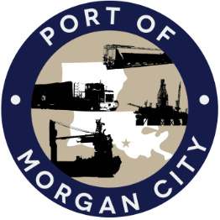

AGENDA

MORGAN CITY HARBOR AND TERMINAL DISTRICT
Regular Meeting of March 11, 2019 – 5:00 p.m. – 7327 Highway 182

- Call to Order

2. Roll Call, Invocation and Pledge of Allegiance

3. Minutes
A. Regular Meeting of February 11, 2019

4. Finance Report
A. Presentation and discussion of financial reports for February 2019 – Deborah Garber
B. Invoices

5. Guest(s)/Public Comment
A. United States Coast Guard
B. Corps of Engineers, New Orleans District
C. Micaela Coner, Coastal Protection and Restoration Authority

6. Raymond “Mac” Wade - Executive Director’s Report
A. Consultant – Michael Knobloch, Knobloch Professional Services, LLC
B. Consultant – Clay Breaud, Providence/GSE
C. Cindy Cutrera, Manager of Economic Development

7. Gerard Bourgeois - Legal Report

8. New Business
A. Discussion and any action on adoption of millage rate(s) for tax year 2019

9. Old Business
A. Discussion and any action on leasing, improvements, maintenance and repairs to facility(ies), including Coast Guard lease(s), electrical modification to VTS room and Brice Civil Constructors lease
B. Discussion and any action regarding the U.S. Department of Homeland Security grant program, including request for proposals, bids, purchases, maintenance for equipment, software and NOAA ports system(s)
C. Discussion and any action on Atchafalaya River Channel including dredging and sediment management, equipment purchases, reports, survey services, consulting services, economic study(ies), landowner agreements and cooperative agreement(s)
D. Discussion and any action on State Project No. H.013795(321) Port Improvements, Morgan City Rail and Dock Rehabilitation, Railroad Track Repair and Maintenance, including authorization to award, certificate of compliance with bid law, and notice to proceed on Phase I

10. Executive Session. Discussion regarding suit against Crosby Marine Transportation, LLC for damage caused to the Morgan City Harbor and Terminal District’s NOAA Meteorological Station #2 in the Atchafalaya River

11. Adjournment

In accordance with the Americans with Disabilities Act, if you need special assistance, please contact Tori Henry at 985-384-0850, describing the assistance that is necessary.

